**Content Marketing Strategy for CODTECH**

# Brand Overview

**Brand Name:** CODTECH

**Industry:** Edtech / Online Internships

**Primary Offering:** Virtual internship in digital marketing and more for student and young professionals.

**Objective:** Empower learners with real world digital skills through hands on task.

# Marketing Objectives

* **Increase Brand Awareness**  
  Position CODTECH as a top choice for digital internships in India.
* **Drive Website & Blog Traffic**  
  Attract students and professionals via search engines and social media.
* **Boost Internship Applications**  
  Encourage applications through persuasive content.
* **Establish Thought Leadership**  
  Build CODTECH’s reputation as a trusted, youth-driven, and skill-oriented brand.

# Target Audience

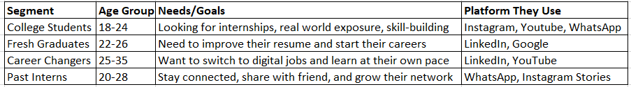

**Demographics**:

* Age: 17–30
* Location: Urban and Tier 2 cities in India
* Interests: Digital marketing, coding, tech trends, startup culture, career development

# Blog Topics

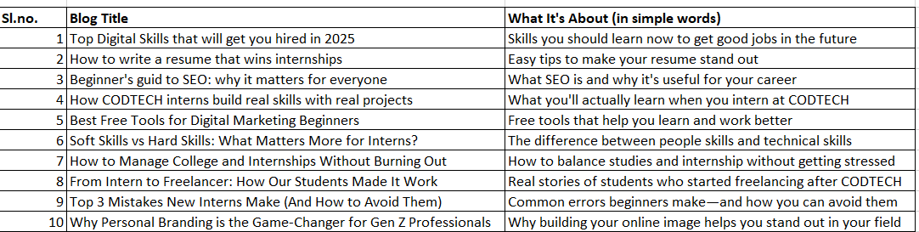

# Promotional Channels

